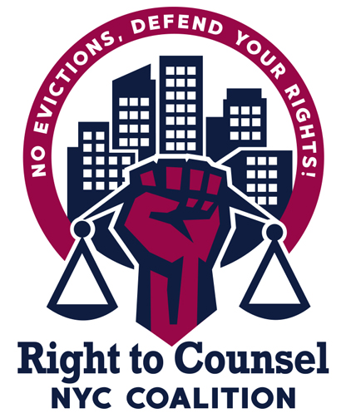

**RTCNYC Tool 12.3.3.12 Plan for the People's Tribunal on Evictions in NYC**

**October 29, 2019**

* 12pm--Set up art, tables. Etc.
* 3pm---Tenants Rights Info Fair begins. Legal clinic or storytelling booth could take place down the hall.
  + Set up begins in the main room
    - wall where people can use stickies or write on butcher paper their stories of displacement
  + DJ sets up and begins to play background music or maybe the DJ plays at the end and we hook up a playlist until the band plays.
* **5-5:30pm: MC: Opening and welcome and welcomes the band**
  + Tell band to be there for 1 hour 5pm-6pm for arrival, set up and they will start to play at 5:15pm
  + Interpretation point people should be giving out equipment, checking it, etc., in the meantime.
* **6pm: Clean up the info fair downstairs?**
* **6pm:** Opening Ceremony {slideshow of pictures from RTC orgs to play in the background)
  + MC: Opening and welcome (10 min)
    - Why we are doing the tribunal
    - acknowledgment/honoring of the land and the Lenape
    - Presentation of Altar
      * chant/song/shared prayer?
  + presentation of our citywide demands (10 min)
    - People to present: 2 demands per org/group
    - Power to organize video
      * Pass out RTC petition
  + Explanation of how the tribunal will work (10 min)
    - Welcome and message of solidarity
    - MC:
      * Presentation of the Jury
      * Introduce time keepers
      * Interpretation rules
* 6:30pm: Tribunal begins! MC back on the mic!
  + 6:30-7:15: RTC Prepared Testimonies (7 min each org):
    - BK --landlord
    - BX-landlord
    - BX--landlord
    - Queens--landlord
    - OCA--- Brooklyn & Bronx Justice in Housing Court coalition
  + 7:15--8:30pm: MC opens up the Open Public Testimonies (3 minute limit=30 testimonies; 2 min=45 testimonies)
* 8:30pm: launch/announcement of the eviction defense network by a Tenant Leader
  + Call to action
    - Commitment card with invite to the 11/21 orientation for eviction defense network
    - Attend OCJ hearing?
* 8:40pm: Jury to issue indictments and endorse city wide demands
* 9pm: closing song/chant (have this filmed by photographer) Put this on social media!

**Materials Needed: (bolded means it’s already done/prepared)**

* For Registration Table:
  + Blank sign in sheet
  + Print out from Eventbrite
  + Commitment cards
  + Testimony sign up cards
  + Sign in sheet for legal clinic
  + Interpretation sign in sheet
  + Interpretation equipment and Batteries
  + Buttons
  + EFNYC cards
  + FAQs
  + Eviction Pamphlets
  + 11/21 orientation flyer
  + NYCHA flyer
  + Banners
  + Demands flyers
  + Power to Organize Campaign Materials
  + OCJ hearing Flyers
* Mic system/audio system, NWBCC, FTC and Rob
* 2 Projectors
* Projector Screen, will make with fabric that SB brings
* 2 Laptop with cables to connect, SB, CMS and CASA to bring
* USB with slideshow of pictures, SB/AF
* Demands posters
* WE posters/placards
* Water
* Napkins
* Plates
* Volunteer list
* Facilitators agenda